Kubernetes Task-2

Task Description:

Create the K8s EKS,further you have to do the deployment of the Nginx application and access the application outside the cluster.

Techstacks needs to be used :

AWS EKS
EKSCtl
Kubectl
AWS: EC2
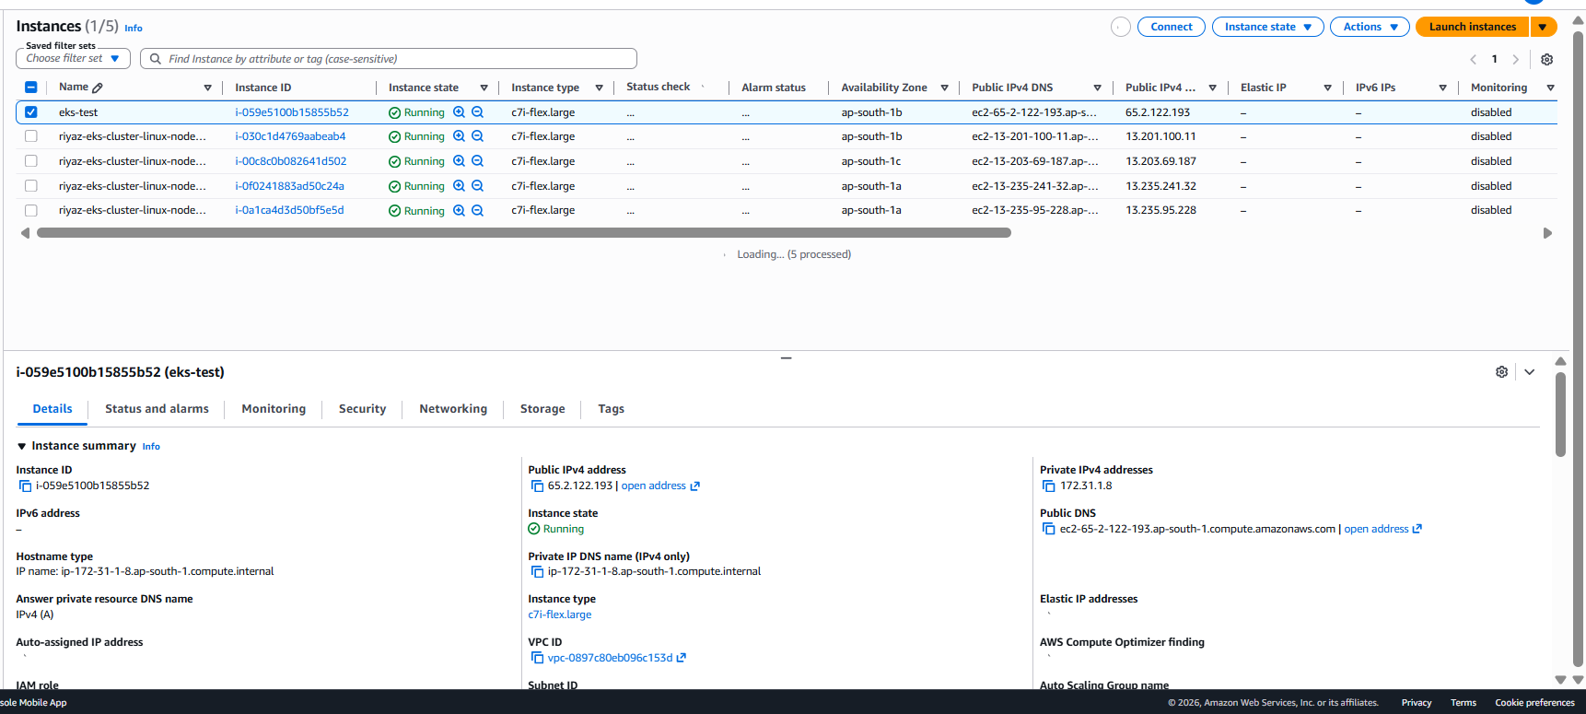

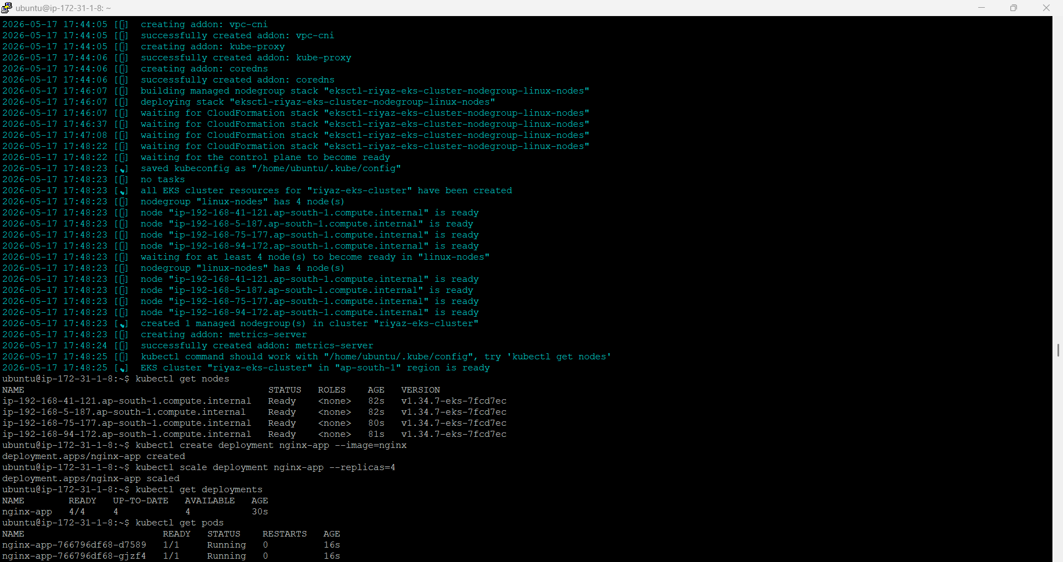
After EKS Creation:

